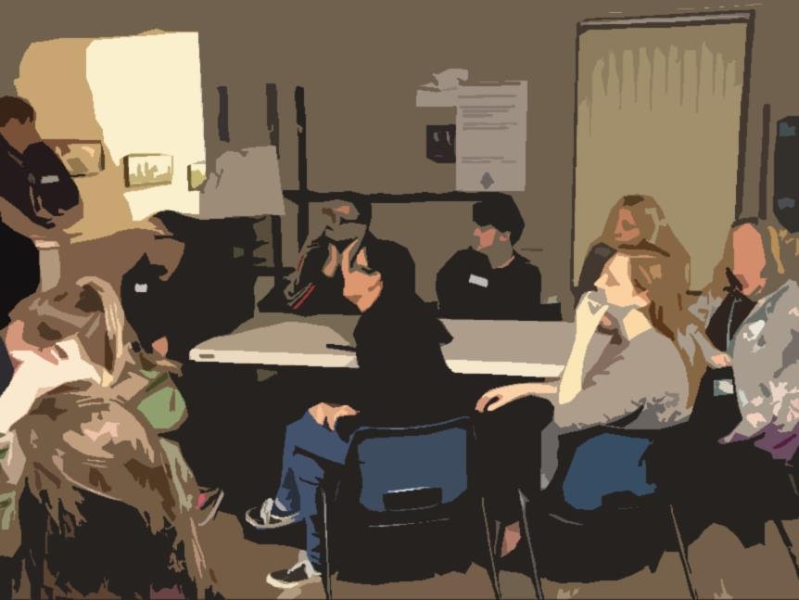
This form should be completed and submitted to CCNI as part of your annual return.

Please read the notes before completion.

Should you need further help contact your Support Officer or The Scout Foundation N.I.

Please read the notes at the end when filling in this form. When complete the form should be signed and scanned then uploaded up on to the CCNI website when completing your annual report.
1.Charity Name as listed on the Charity Register | ___________________________Scouting Ireland
2. Any other names the charity is known by
3. Financial year the report is for  Eg. 01-Sep-20 to 31-Aug-21 | ___________________________
4. CCNI Charity Registration Number | NIC_______________________
5. The address from which the Charity Operates (usually your Scout hall)
This should be the address that the charity used when registering unless it has changed.

6. The names of all our Trustees at the date this report was approved plus any who stepped down as a trustee during the year | Current Trustees  Trustees who stepped down
7. A summary description of the purposes of the charity

The aim of Scouting Ireland is to encourage the physical, intellectual, character, emotional, social and spiritual development of young people so that they may achieve their full potential and as responsible citizens, to improve society.

The Charity’s purposes are:
The advancement of education
The advancement of citizenship or community development

*8. The name of any person, or body of persons, permitted by the trusts of the charity to appoint one or more new charity trustees and a description of the method used to make such appointments  If there is any individual or organisation with the power to appoint charity trustees, such as another charity or a government department, provide their details, the relevant powers, and methods of appointment. | N/A
*9. Include details of any funds held by the charity as a custodian trustee  This is mandatory for charities preparing accruals accounts. | N/A
10. Charity’s Main Activities and Achievements during the year.
10.1 To further these purposes for the public benefit, we carried out the following activities:

10.2 The main achievements of the [charity] in the year were:

11. How is the Group doing financially?
A review of the charity’s financial position at the end of the year:
In the financial 20[ ]to 20[ ] the Charity had an income of £[ ] and an expenditure of £[ ].

12. How has the Group ensured members have not come to harm?

All volunteers receive training in Safeguarding, Programme (youth work) skills and adventure skills. There is oversight of all activity by the Group Leader and the Group Council. Parents are regularly communicated with. All activities are carefully planned and the appropriate equipment used.

13. How has your Group ensured that any private benefit to your volunteers has been incidental to the public benefit of your work?

Volunteers gain additional transferrable skills but this is incidental to the work that they do and are the skills that they require to undertake that work.
14. A statement that the Trustees have had regard to the CCNIs guidance on Public Benefit.

We the Trustees of ____________________________________Scouting Ireland can confirm that in setting our objectives and planning for the year that we have given careful consideration to the Charity Commission for Northern Ireland’s guidance on public benefit to ensure that the activities have helped to achieve the charity’s purposes and provide a benefit to the beneficiaries.

15. This report was approved by the Trustees (Group Council) on

Date:____________________________

16. Signature of Trustees. (This should be signed by 2 Trustees approved by the Group Council)

Trustee 1: ________________________________________ Date:________________________

Trustee 2: ________________________________________ Date:________________________

NOTES FOR COMPLETION OF THE TEMPLATE INCLUDE:

- Enter the name of your Charity here as it is listed on the Charity Commission NI register. E.g. 29th Derry, Garvagh, Scouting Ireland
- Enter any other names your charity is known as.
- This would normally be the Scout Year i.e. 1st September to 31st August
- Enter your Charity Commission NI Registration Number here. If you have forgotten it you can find it out online at http://www.charitycommissionni.org.uk/charity-search/ or by contacting Scout Foundation NI.
- Enter the address that you gave CCNI for your Group. This should be the address of where you meet.
- List the names of Trustees (Group Council Members) that held the position of trustee at the date this report was approved by your Group Council. Also list separately any Trustees that stepped down during the year.
- This section is pre-filled in for you using an answer previously agreed with CCNI.
- N/A
- N/A
- In this section list the main activities carried out by your Group (Charity) in the last year. Items could include a summary of: The number/type of camps, hikes and outings; environmental projects; cross community work/projects; joint work/projects with other organisations, list efforts to recruit new members, adult and young people, etc. This work is carried out by how many volunteers in your Group.

List the achievements of the Group e.g. the number and type of badges awarded e.g. Special Interest or Adventure skills; the number of Chief Scout Awards; the number of An Gaisce or Duke of Edinburgh Awards; the number of Explorer Belts; any adult awards awarded during the year; have your or people in your Group won any awards as a result of the work the Group undertakes.
Have you refurbished your Scout Hall or built a new one?

How have these activities helped young people? You could mention engagement, participation, teamwork and leadership skills, planning skills, a place to go, a sense of achievement and confidence, a sense of challenge, etc.?

Finally, how do you ensure that you are open to all young people?

- Tell CCNI how the Group is doing financially - include your income and expenditure figures for the reporting year. These should be the same amounts as in your accounts. Tell them about any fundraising that you undertook or grants received. Also list any debts that the Group has and how the Trustees plan to get rid of them.
- This section is pre-filled in for you using an answer previously agreed with CCNI.
- This section is pre-filled in for you using an answer previously agreed with CCNI.
- Enter the name of your Charity here as it is listed on the Charity Commission NI register and the date the report was approved by the Group Council.
- Enter the date that this report was approved by the Group Council.
- Two trustees must sign the form.

You can use another format for your Annual Report e.g. your own Groups annual report, but all questions listed here MUST be answered including those marked * that do not apply to SI Groups.

